# JedisDeleteStep

**Objective:**

It is used to delete the key value pairs in the redis server using Jedis client based on given key.

**Attributes:**

|  |  |
| --- | --- |
| **Attributes** | **Description** |
| value_type | To select type as free marker template or handlebar |
| data_type | To select which type of data need to enter. Ex: List, Set, HashMap and String. |
| key | To enter the key to get the respective value |
| plugin_name | To connect with redis server based on the plugin credentials |

**Sample config.json:**

{

"workflows": [

{

"name": "jedis-delete",

"id": 200,

"trigger": "rest",

"expression": "jedis-delete",

"method": "GET",

"steps": [

{

"type": "start",

"id": 1,

"next": {

"start": "start"

}

},

{

"value_type": "ftl",

"data_type": "String",

"key": "address",

"plugin_name": "jedis-delete",

"type": "jedis-del",

"id": "start",

"next": {

"success": "jedis-delete-success",

"failure": "hangup"

}

},

{

"variable_name": "address",

"http_response_code": "200",

"response_content_type": "text/html",

"value_type": "hb",

"type": "send",

"id": "jedis-delete-success",

"next": {

"success": "hangup",

"failure": "hangup"

}

}

]

}

],

"filters": [],

"server": {},

"plugins": [

{

"id": 24,

"name": "jedis-delete",

"host": "localhost",

"type": "jedis-plugin",

"version": "1.0",

"category": "jedis"

}

]

}

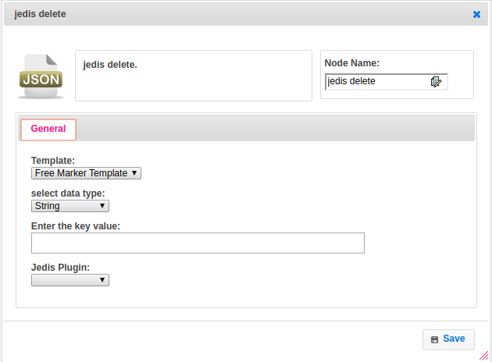

**Executor Description:**

In executor class first it will connect to redis server by using Redis Plugin Handler based on host and port values and Remove the specified keys. If a given key does not exist no operation is performed for this key, For each data type have respective methods to store data. But as of write now we are supporting String data type only. Returns the number of keys removed.